

Mawlana Bhashani Science and Technology University

Lab-Report

Lab Report No: 03
Lab Report Name: Threads on Operating System
Course code: ICT-3110
Course title: Operating System Lab
Date of Performance:
Date of Submission:

Submitted by Submitted To
Name : Maskur Al Shal Sabil
ID: IT 18021
3rd year 1st semester
Session : 2017-2018
Dept of ICT
Nazrul Islam
Assistant Professor
Dept. of ICT,
MBSTU.

1.what is thread ?

Thread : A thread is a path of execution within a process. A process can contain multiple threads. The thread is a lightweight process that can be managed independently by a scheduler. It improves the application performance using parallelism.
A thread shares information like data segment, code segment files etc. with its peer threads while it contains its own registers, stack, counter etc.
2.Types of thread.
The two main types of threads are user-level threads and kernel-level threads.
User-level thread :
The user-level threads are implemented by users and the kernel is not aware of the existence of these threads. It handles them as if they were single-threaded processes. User-level threads are small and much faster than kernel level threads. They are represented by a program counter(PC), stack, registers and a small process control block. Also, there is no kernel involvement in synchronization for user-level threads

Kernel-Level Threads
Kernel-level threads are handled by the operating system directly and the thread management is done by the kernel. The context information for the process as well as the process threads is all managed by the kernel. Because of this, kernel-level threads are slower than user-level threads.
3. Implementation of thread .
There are two ways of implementing a thread package:
- In user space
- In kernel
Threads implementation in the user space
In this model of implementation, the threads package entirely in user space, the kernel has no idea about it. A user-level threads package can be executed on an operating system that doesn't support threads and this is the main advantage of this implementation model i.e. Threads package in user space.
Threads implementation in the kernel
In this method of implementation model, the threads package completely in the kernel. There is no need for any runtime system. To maintain the record of all threads in the system a kernel has a thread table.
A call to the kernel is made whenever there is a need to create a new thread or destroy an existing thread. In this, the kernel thread table is updated.
A simple implementation of threads is given below :
#include <pthread.h>
#include <stdio.h>
#include <stdlib.h>

void* func(void* arg)
{
// detach the current thread
// from the calling thread
pthread_detach(pthread_self());

printf("Inside the thread\n");

// exit the current thread
pthread_exit(NULL);
}

void start_thread()
{
pthread_t ptid;

// Creating a new thread
pthread_create(&ptid, NULL, &func, NULL);
printf("This line executes before thread terminates\n");

// The following line terminates
// the thread manually
// pthread_cancel(ptid);

// Compare the two threads created
if(pthread_equal(ptid, pthread_self()))
printf("Threads are equal\n");
else
printf("Threads are not equal\n");

// Waiting for the created thread to terminate
pthread_join(ptid, NULL);
printf("Thread end's\n");
pthread_exit(NULL);
}
// Driver code
int main()
{
start_thread();
return 0;
}
Code output :
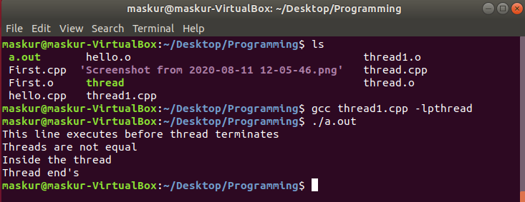
Code Explanation :
pthread_create: used to create a new thread
int pthread_create(pthread_t * thread,
const pthread_attr_t * attr,
void * (*start_routine)(void *),
void *arg);
Parameter:

- thread: pointer to an unsigned integer value that returns the thread id of the thread created.
- attr: pointer to a structure that is used to define thread attributes like detached state, scheduling policy, stack address, etc. Set to NULL for default thread attributes.
- start_routine: pointer to a subroutine that is executed by the thread. The return type and parameter type of the subroutine must be of type void *. The function has a single attribute but if multiple values need to be passed to the function, a struct must be used.
arg: pointer to void that contains the arguments to the function defined in the earlier argument
pthread_exit: used to terminate a thread
Syntax:
void pthread_exit(void *retval);
Parameters: This method accepts a mandatory parameter retval which is the pointer to an integer that stores the return status of the thread terminated. The scope of this variable must be global so that any thread waiting to join this thread may read the return status.
pthread_join: used to wait for the termination of a thread.
Syntax:
int pthread_join(pthread_t th,
void **thread_return);
Parameter: This method accepts following parameters:
- th: thread id of the thread for which the current thread waits.
- thread_return: pointer to the location where the exit status of the thread mentioned in th is stored
pthread_self: used to get the thread id of the current thread.
Syntax:
pthread_t pthread_self(void);
pthread_equal: compares whether two threads are the same or not. If the two threads are equal, the function returns a non-zero value otherwise zero.
Syntax:
int pthread_equal(pthread_t t1,
pthread_t t2);
Parameters: This method accepts following parameters:
- t1: the thread id of the first thread
- t2: the thread id of the second thread
pthread_cancel: used to send a cancellation request to a thread
Syntax:
int pthread_cancel(pthread_t thread);
Parameter: This method accepts a mandatory parameter thread which is the thread id of the thread to which cancel request is sent.
pthread_detach: used to detach a thread. A detached thread does not require a thread to join on terminating. The resources of the thread are automatically released after terminating if the thread is detached.
Syntax:
int pthread_detach(pthread_t thread);
Parameter: This method accepts a mandatory parameter thread which is the thread id of the thread that must be detached.

